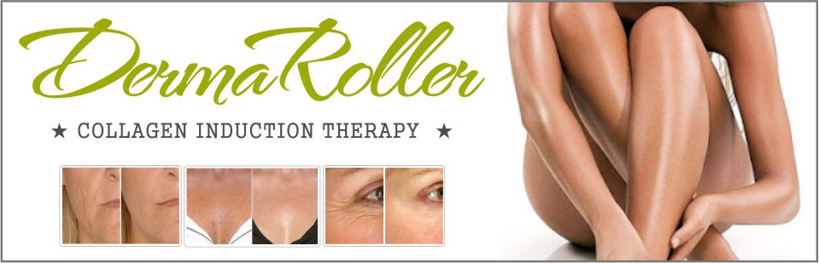

DermaRoller | Skin Needling

The dermaroller is an incredible device which naturally stimulates the growth of new collagen and elastin in your skin. Stretch marks, acne scars, wrinkles and uneven, pitted skin are all due to a lack of collagen. By using a dermaroller you keep the collagen levels fresh and the skin can repair and renew itself.

As we age the body slows down production of collagen. The collagen layer gradually diminishes, which causes the skin that rests upon it to wrinkle and sag. The dermaroller treatment can be performed on any part of the body and has been shown to be very effective at improving stretch marks, acne scars, wrinkles and all over skin rejuvenation.

The skin consists of two main layers - the epidermis and the dermis. The dermis has an extremely slow turnover. The half-life of dermal collagen is about fifteen years.

The dermaroller is a revolutionary breakthrough in skin renewal giving fantastic results with acne scars, stretch marks and wrinkles!

What does that mean? You are born with a certain amount of collagen in the dermis.
- When you are 15 years old, 50% of the original collagen remains (the rest has been replaced)
- When you are 30 years old, 25% of the original collagen is still in your skin
- When you are 45 years old, 12.5% of the original collagen is still in your skin
- When you are 60 years old, 6.25% of the original collagen is still in your skin
- And again, the newly formed collagen has a half-life turnover of about 15 years

“The big deal with dermarolling is that you can trick the body to trigger collagen and elastin much sooner than the natural rate of turnover”

The dermaroller needles (1mm+) that reach the dermis causes tiny microinjuries in it and the body sees it as a high priority to fix them. These micro-injuries trigger new collagen growth.

Ablative methods such as acid peels or ablative lasers can’t be used to reach the dermis due to the risk of scarring and hypopigmentation. But a dermaroller very easily can go that deep because it does not ablate the skin, it only pricks it. Since the pricks are surrounded by untreated skin, the regeneration happens very quickly.

The dermaroller speeds up the dermal proteins (collagen and elastin) in the dermis and this can slow down the signs of skin ageing.

“The Dermaroller is more effective than laser and surgery for scar reduction, stretch mark removal and wrinkle elimination”

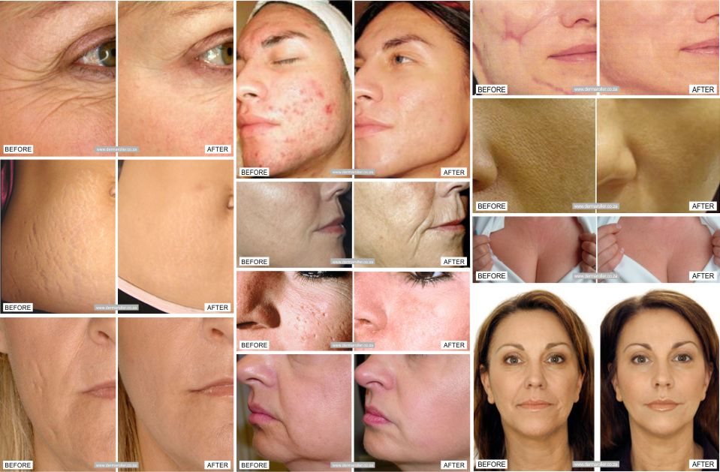

Dermarollers have become increasingly popular over the last decade, and many women and men use dermarollers for problems such as:
- Stretch marks
- Acne and surgical scars
- Wrinkle and anti-ageing
- Ice-pick and chicken pox scars
- Enlarged pores
- Lack of skin firmness
- Age spots and sun damage
- Hair loss
- Hyper pigmentation

The dermaroller benefits can be reaped for years to come as far as anti-ageing is concerned. As well as increasing the absorption and efficacy of your anti-ageing skin care products with continued use the stimulation of cells will also result in a faster renewal cycle of the epidermis and stimulate new collagen production. This will increase the thickness of the upper layer of the epidermis, improve the skin’s integrity and leave it looking plumper and younger with a healthy glow.

How exactly does the Dermaroller work?

As you roll the dermaroller over your skin, it creates pin point punctures into the dermis – the majority of which are simply pushing your pores open temporarily. This is perceived by the body as damage, which stimulates the release of growth factors that trigger the production of collagen and elastin. The human body reacts to any injury by initiating the healing process but usually it will only heal as far as it must to keep you healthy – which is different to healing to a cosmetic level. By persistently triggering the healing process you encourage the body to continue healing until the job is finished.

This process of skin remodelling can go on for months after each dermaroller treatment, but noticeable results can be seen within 2 – 4 weeks. Your skin naturally renews itself every 40 days so with little stimulation changes can be dramatic and fast.

Celebrities like Angelina Jolie is reported to have tried dermaroller therapy after being introduced to it by husband Brad Pitt, who is himself thought to have undergone treatments to combat acne scars. Others like Jennifer Aniston reportedly use the dermaroller treatment to give herself a fresh faced, natural look.

Amazing Benefits of the Dermaroller .....
- The dermaroller causes a 40% improvement in ageing and a 60-75% improvement in scar reduction in only 5 to 6 treatments!
- The dermaroller induces maximum absorption of your best wrinkle cream or any anti-ageing creams, giving you an 'instant facelift' - scientific studies have shown only 0.3% of the active ingredients in traditional cosmetics are able to penetrate skin, so 97.7% of them are wasted. Remembering that any cream or treatment you use on the face or body immediately after rolling will be up to 100x more potent, so it is recommended that those using Retin A should NOT use it on the days that you will be rolling. High doses of vitamin A can be toxic.
- The dermaroller literally rolls away your scars, wrinkles and stretch marks before your eyes without harmful effects
- Dermarollers literally 'trick' your skin into turning back the clock by destroying old skin cells and scar tissue, and then replacing them with brand new skin cells
- Highly effective treatment for surgery scars, burn scars, acne scars, chicken pox scars, pitting of the skin, large pores and much more
- Dermarollers are very affordable considering what a trip to the dermatologist or skin clinic will cost you
- Tiny needles puncture the skin, thus stimulating collagen production and 're-sets' the cell cycle back to adult stem cells (differentiated stem cells capable of dividing and creating new cells)
- Provide astonishing results that are a powerful non-surgical treatment by rejuvenating the skin - just like a laser or chemical peel does, but without the healing, skin damage, down time, and cost
- Similar results to laser treatment, chemical peels and dermabrasion at a fraction of the cost
- Remove loose skin, lines and wrinkles on the face
- Improve thinning hair and hair loss/alopecia
- The dermaroller lessens dimpling of the skin, improves skin colour and texture of aged skin
- The dermaroller is a great home treatment option with no side effects and fast recovery
- The dermaroller can dramatically reduce all types of scarring anywhere on the skin with the proper series of treatments
- The effectiveness of the active ingredients in topically applied skin care products (such as Vitamin E and C) is greatly improved when using the dermaroller as it allows those ingredients to reach below the outer surface of the skin
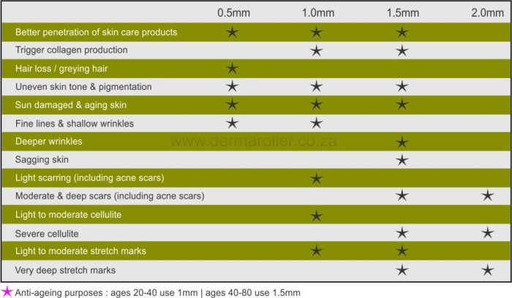
- Ultimately the dermaroller is the future of the non-surgical facelift

