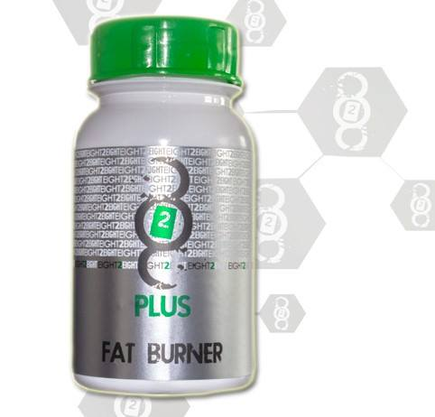

828 Plus FATBURNING

The 828 PLUS works in 2 ways. One it suppresses appetite and two it changes your metabolism so that you burn fat naturally all times. As it changes metabolism the ideal course time is 8 weeks (2 courses) to feel the maximum effects.
Metabolism takes 4-5 weeks to start to change so this is why two courses are needed to gain the full effect.

Increased metabolism may result in an initial increase in appetite but this is short term and after the initial course will start to decrease naturally. The results of 828 mechanism is way healthier in the long run at maintaining the weight and the size
828 Plus suppresses appetite and cravings while at the same time uses the body’s own energy to work on fatty areas such as the stomach, hips and thighs.
828 Plus is specially designed to effectively control appetite, block the absorption of dietary fat and accelerate metabolism. The carefully designed formula clears the system by driving away harmful toxins and prevents the reuptake of fat. Targeted areas for fat burning include the abs, thighs and buns regions.
828 Plus uses the body’s own energy, therefore you will not experience energy spikes or shakes such as is most frequent in most current fat burners on the market.
Benefits Include:
1) Speed up the fat consumption: the biotical ingredients will quickly burn fat and speed up the ATP circulation rate to boost the fat decomposing rate in the targeted areas
2) Block fat absorption: increase satiety by inhibition reuptake of 5-HT, decrease the absorption of dietary fat and guarantee enough intake of daily essential nutrients.
3) Accelerate the fat decomposing rate: the lipolysis enzyme ingredient inside can actively decompose the fat in the waist, belly, hip and thighs aiding in reducing the waist size.
These are the benefits and the new added benefits:

· Suppresses appetite
· Burns Fat through increased metabolism rate
· Suppresses increased uptake of fat and provides daily nutrients
· Stimulation free so no ups and downs during the day

New benefits include:

· No side effects such like dry mouth
· Now applicable for professional athletes as there are no banned substances in the product
· The product is now applicable for people with diabetes

With regards to the ingredients they are as follows:

Function | Ingredient
1. Active | Synephrine 6% (Citrus Aurantium)
2. Active | Guggul Ext 2.5% Guggulsterone
3. Active | Caffeine Anhydrous
4. Active | Bioperine
5. Active | Green Tea Extract 95%
6. Active | White Willow Bark Extract 15%
7. Active | Alpha-Lipoic Acid 99.8%
8. Excipient | Microcrystalline Cellulose PH102
9. Excipient | Magnesium Stearate

Info in relation to the numbers above for Function and Ingredient:

- This review summarizes the published as well as unpublished human studies involving Citrus aurantium (bitter orange) extract and its primary protoalkaloid p-synephrine, providing information and an assessment of the safety and efficacy of these widely used products. The results of over 20 studies involving a total of approximately 360 subjects that consumed p-synephrine alone or in combination with other ingredients are reviewed and critiqued. Over 50 % of the subjects involved in these studies were overweight/obese, and approximately two-thirds of these overweight/obese subjects consumed caffeine (132-528 mg/day) in conjunction with p-synephrine (10-53 mg/day). Bitter orange/p-synephrine containing products were consumed for up to 12 weeks. Approximately 44 % of the subjects consumed a bitter orange/p-synephrine only product, while the remainder consumed a complex product that contained multiple ingredients in addition to p-synephrine. In general, bitter orange extract alone (p-synephrine) or in combination with other herbal ingredients did not produce significant adverse events as an increase in heart rate or blood pressure, or alter electrocardiographic data, serum chemistry, blood cell counts or urinalysis. p-Synephrine alone as well as in combination products were shown to increase resting metabolic rate and energy expenditure, and modest increases in weight loss were observed with bitter orange extract/p-synephrine-containing products when given for six to 12 weeks. Longer term studies are needed to further assess the efficacy of these products and affirm their safety under these conditions.

- This ingredients function is to assist with metabolism and thyroid function

- This is probably the ingredient that your clients asked about as it states Caffeine. At this dose the effect is not stimulating. This is also a plant based ingredient and not a bean based ingredient so will provide not provide any ‘buzz’. The International Society of Sports Nutrition states that anhydrous caffeine is more effective in enhancing performance than coffee in trained athletes who use low to moderate doses. I don’t know if you have taken the product yet? There is no buzz on the product. Discuss with your client and let me know what they say but give them the info and advise them to try it out. There is no stimulation effect with the new 828 PLUS

- BioPerine is the only product sourced out of piperine (pepper) to obtain a patented status for its ability to increase the bioavailability of nutritional compounds. Secondly, it is the only source from piperine to have undergone clinical studies in the U.S. to substantiate its safety and efficacy for nutritional use. If you lack the one ingredient that can change the way your body looks, just go for BioPerine

- Green tea is also commonly used in diet pills because of its ability to raise the metabolism and burn fat. In November 1999, the American Journal of Clinical Nutrition published the results of a study at the University of Geneva in Switzerland. Researchers there found that men who were given a combination of caffeine and green tea extract burned more calories than those given only caffeine or a placebo. This is the reason for point 3 added above. It is not to provide stimulation within the client but rather to assist the green tea extracts to work better

- Willow bark is also used for fever, the common cold, flu, and weight loss

- R-Lipoic Acid (RLA) is one of the most important and exciting new nutraceutical compounds to hit the market. It is a powerful antioxidant, a critical co-factor in ATP production and has been shown to be more effective by a factor of 10 over the commercially available Alpha Lipoic Acid in several bio-tests.

- Excipient that is purified, partially depolymerized alpha cellulose derived from purified specialty grades of wood pulp. A white, odourless, tasteless, free flowing powder. Used to assist the the other ingredients for better flow within the body

- Magnesium stearate is often used as an anti-adherend in the manufacture of medical tablets, capsules and powders. In this regard, the substance is also useful, because it has lubricating properties, preventing ingredients from sticking to manufacturing equipment during the compression of chemical powders into solid tablets; magnesium stearate is the most commonly used lubricant for tablets.

